ASSIGNMENT NO 5:

QUESTION NO 1:

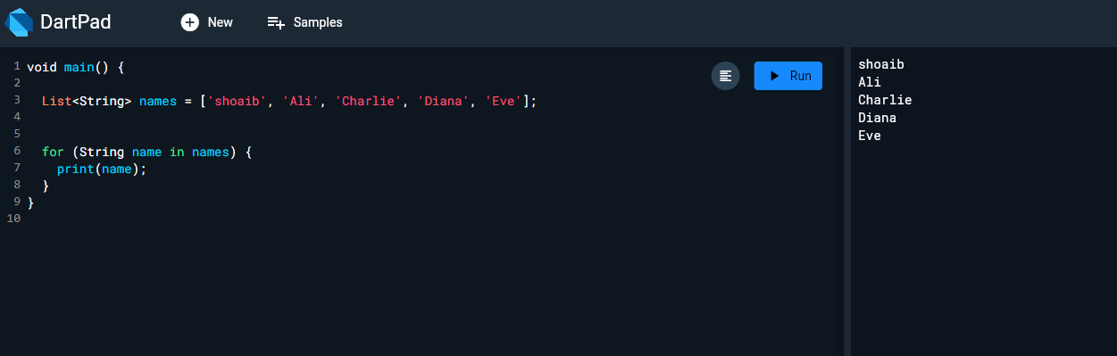

QUESTION NO 2:

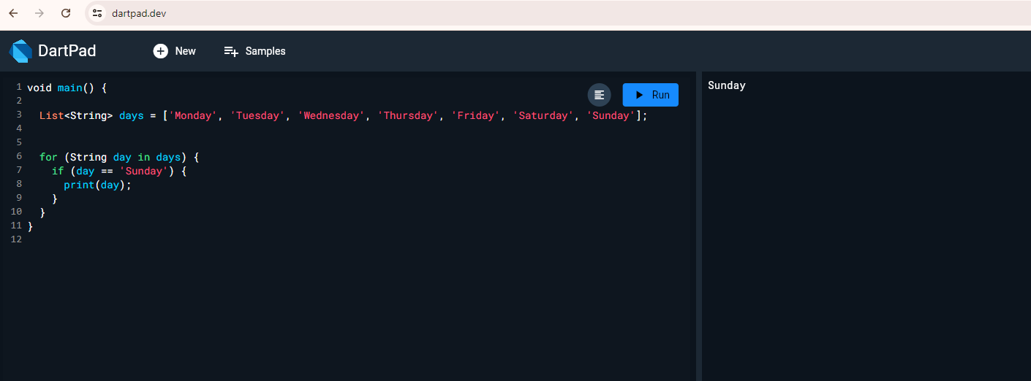

QUESTION NO 3:

